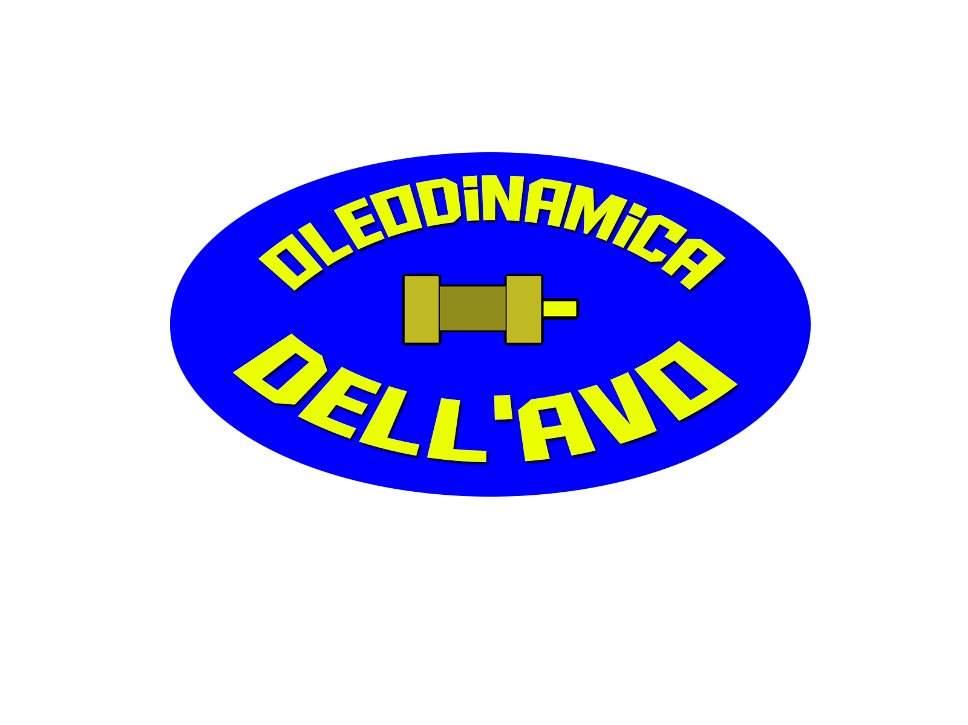 |  |  |  | Oleodinamica Dell’Avo S.r.l.  Production of hydraulic cylinders and control units
Oleodinamica Dell'Avo S.r.l. is the result of experience, technology, professional seriousness towards customers and suppliers, gained in over 30 years of activity.
The products find application in many sectors where hydraulics is a primary part in industrial constructions.
The hydraulic cylinders are designed and built by consulting our customers in order to obtain a product that matches the project requirements and the market costs.
In addition to being manufacturers of new cylinders, the company also deals with the overhaul and maintenance of used products, including those of competitors' brands, trying to spend as little time as possible to carry out the repairs, guaranteeing less downtime as possible.
The production is mainly based on special cylinders designed by the customer and actuators with ISO standards also in 316 stainless steel.
The company is supported by a web configurator that allows the designer to download the chosen hydraulic cylinder in 1.1 scale to be placed within the project without having to draw it.
Availability, complete customization of the product and efficiency are our main characteristics, we always try to satisfy the customer even on batches of a few pieces.

Via po 26
Rozzano – 20089
Q.to stampi - italy
 |  | 02 27 20 88 51
 |  | Oleodellavo  @hotmail.com
 |  | www.oleodellavo.it

